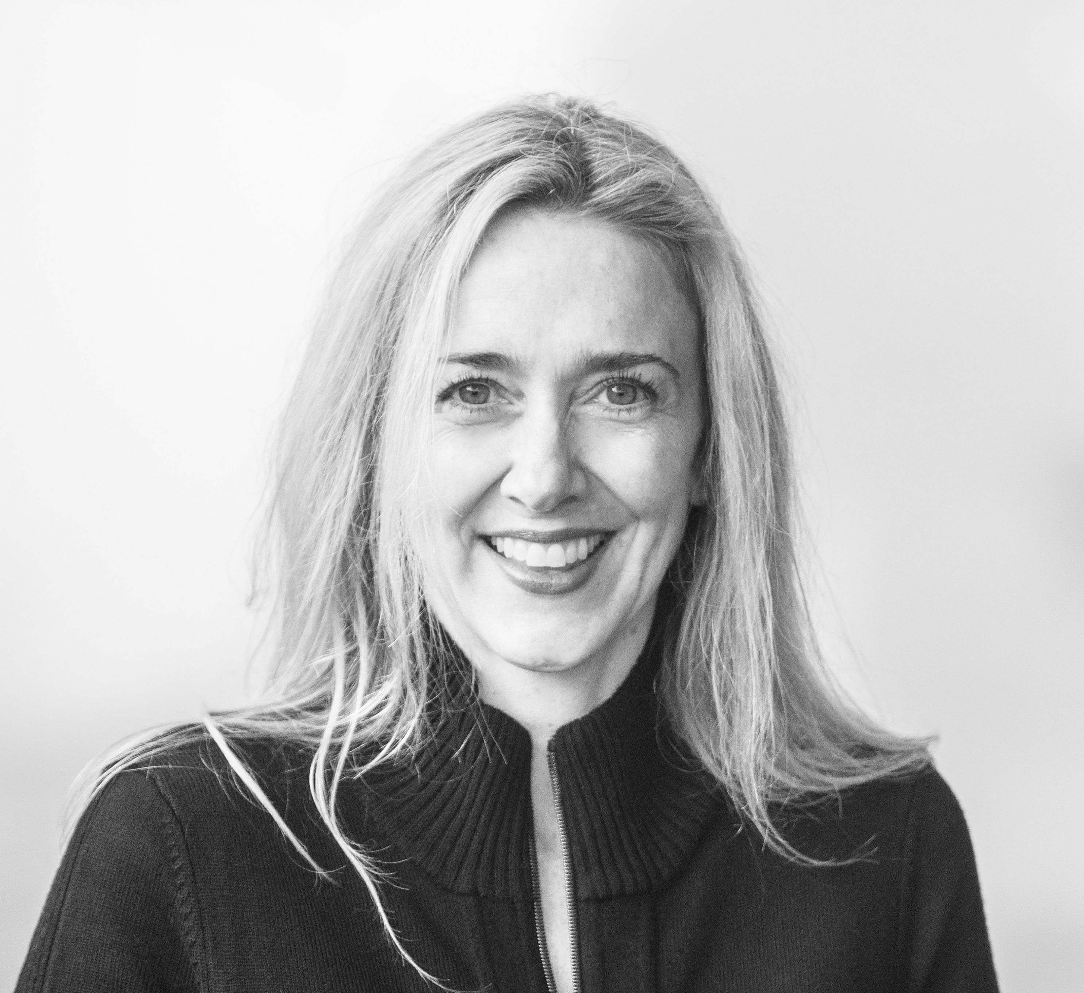

Laura Van Horne

lvhlee@yahoo.com

www.lauravanhorneart.com

I create art because I have to. I am driven by curiosity and gather inspiration from a variety of places: nature, photography, humor, and everyday objects. I enjoy many styles of painting and use a variety of challenging, innovative mediums and materials to create art.

My abstract ink and resin paintings have evolved from years of experimentation with an elixir of inks, pigments, paints, and resin used on different substrates. It is a meditative process and the result appears organic and scientific with geodes, human cells, irises, and orbs coming to mind.

Laura Van Horne is a mixed-media artist who works in encaustic, acrylic, watercolor, ink, resin, paper and textiles. She was born in Winnipeg, Manitoba, Canada and moved to Seattle, WA in 1994. She studied acrylic and encaustic painting at Pratt Fine Art Center, in Seattle, WA. Laura has participated in a number of group and solo art shows over the past 15 years. She presently paints and teaches out of Gray Sky Gallery, her Seattle studio/gallery space and is represented by SAM Gallery.

For inquiries please call Laura at (206)913-3242

More work can be seen at
Gray Sky Gallery
1631 15th Ave W #210
please call for an appointment. 206 913-3242

